# CSS FLEXBOX

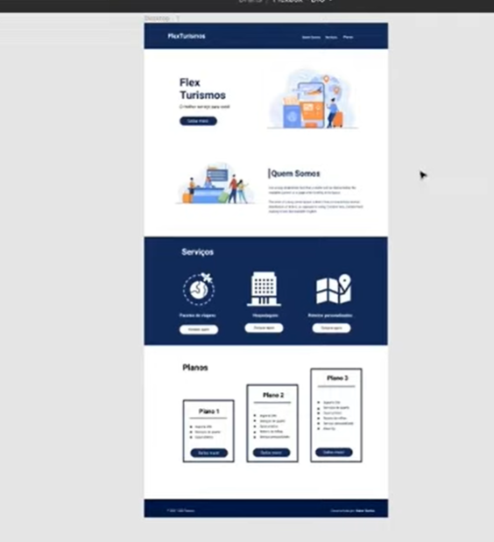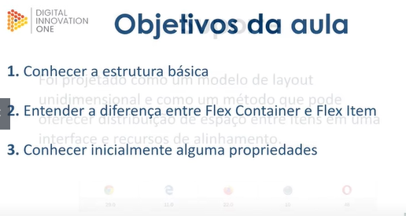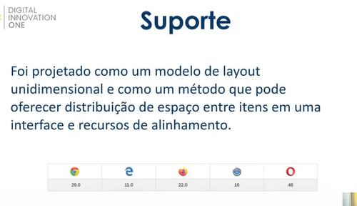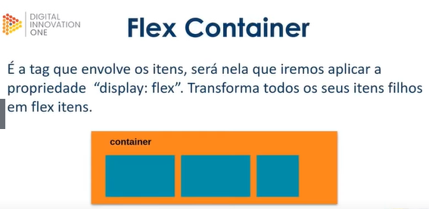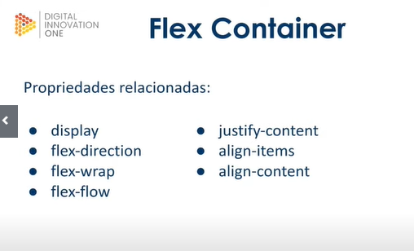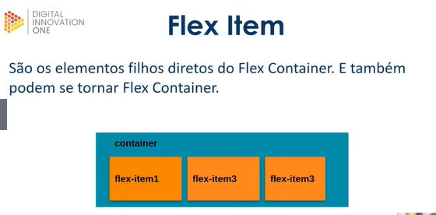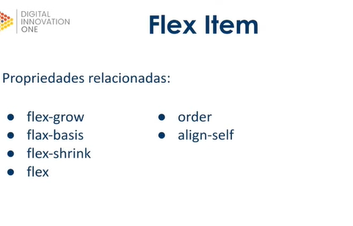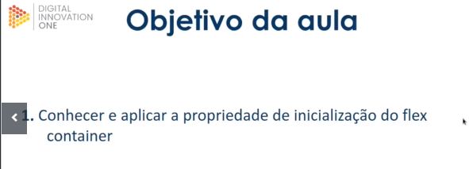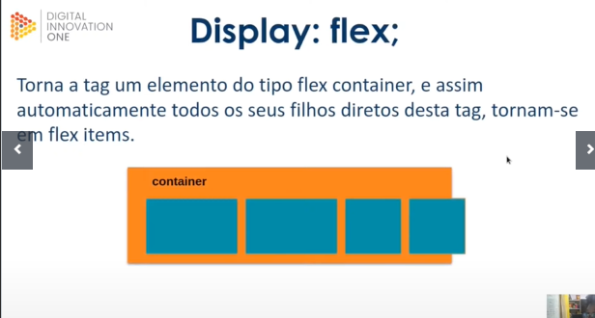

<!**DOCTYPE** html>

<**html** lang="en">

<**head**>

    <**meta** charset="UTF-8">

    <**meta** http-equiv="X-UA-Compatible" content="IE=edge">

    <**meta** name="viewport" content="width=device-width, initial-scale=1.0">

    <**title**> Fundamentos - Display flex</**title**>

    <**style**>

            .flex{

                max-width: 300px;

                padding: 10px;

                border: 2px solid black;

                display:flex;

            }

            .item{

                background-color: aqua;

                margin: 5px;

            }

    </**style**>

</**head**>

<**body**>

    <**div** class="flex">

        <**div** class="item">Item 1</**div**>

        <**div** class="item">Item 2</**div**>

        <**div** class="item">Item 3</**div**>

        <**div** class="item">Item 3</**div**>

        <**div** class="item">Item 3</**div**>

        <**div** class="item">Item 3</**div**>

        <**div** class="item">Item 3</**div**>

        <**div** class="item">Item 3</**div**>

        <**div** class="item">Item 3</**div**>

    </**div**>

</**body**>

</**html**>

<!**DOCTYPE** html>

<**html** lang="en">

<**head**>

    <**meta** charset="UTF-8">

    <**meta** http-equiv="X-UA-Compatible" content="IE=edge">

    <**meta** name="viewport" content="width=device-width, initial-scale=1.0">

    <**title**> Fundamentos - Display flex</**title**>

    <**style**>

            .flex{

                max-width: 300px;

                padding: 10px;

                border: 2px solid black;

                display:flex;

            }

            .item{

                background-color: aqua;

                margin: 5px;

            }

    </**style**>

</**head**>

<**body**>

    <**div** class="flex">

        <**div** class="item">Item 1</**div**>

        <**div** class="item">Item 2</**div**>

        <**div** class="item">Item 3</**div**>

        <**div** class="item">Item 3</**div**>

        <**div** class="item">Item 3</**div**>

        <**div** class="item">Item 3</**div**>

        <**div** class="item">Item 3</**div**>

        <**div** class="item">Item 3</**div**>

        <**div** class="item">Item 3</**div**>

    </**div**>

</**body**>

</**html**>

COLAR AQUI MATERIAL QUE ESTA NA CODEVASF

<!**DOCTYPE** html>

<**html** lang="en">

<**head**>

    <**meta** charset="UTF-8">

    <**meta** http-equiv="X-UA-Compatible" content="IE=edge">

    <**meta** name="viewport" content="width=device-width, initial-scale=1.0">

    <**title**>Fundamento -Flex Direction</**title**>

    <**style**>

        .flex-container{

            margin:0;

            padding:0;

            display:flex;

            list-style: none;

        }

        .flex-item{

            background:blue;

            height: 50px;

            width: 50px;

            line-height: 50px;

            font-size: 20px;

            color: white;

            text-align: center;

            margin:5px

            ;

        }

    .row{

        flex-direction: row;

    }

    .row-revere{

        flex-direction: row-reverse;

    }

    .row-revere li{

        background-color: red;

    }

    .column{

        float:left;

        flex-direction:column;

    }

    .column li{

        background: orange;

    }

    .column-reverse{

        float:right;

        flex-direction: column-reverse;

    }

    .column-reverse li{

        background-color:blueviolet;

    }

    </**style**>

</**head**>

<**body**>

    <**ul** class="flex-container row">

        <**li** class="flex-item">1</**li**>

        <**li** class="flex-item">2</**li**>

        <**li** class="flex-item">3</**li**>

        <**li** class="flex-item">4</**li**>

        <**li** class="flex-item">5</**li**>

    </**ul**>

    <**ul** class="flex-container row-revere">

        <**li** class="flex-item">1</**li**>

        <**li** class="flex-item">2</**li**>

        <**li** class="flex-item">3</**li**>

        <**li** class="flex-item">4</**li**>

        <**li** class="flex-item">5</**li**>

    </**ul**>

    <**ul** class="flex-container column">

        <**li** class="flex-item">1</**li**>

        <**li** class="flex-item">2</**li**>

        <**li** class="flex-item">3</**li**>

        <**li** class="flex-item">4</**li**>

        <**li** class="flex-item">5</**li**>

    </**ul**>

    <**ul** class="flex-container column-reverse">

        <**li** class="flex-item">1</**li**>

        <**li** class="flex-item">2</**li**>

        <**li** class="flex-item">3</**li**>

        <**li** class="flex-item">4</**li**>

        <**li** class="flex-item">5</**li**>

    </**ul**>

</**body**>

</**html**>

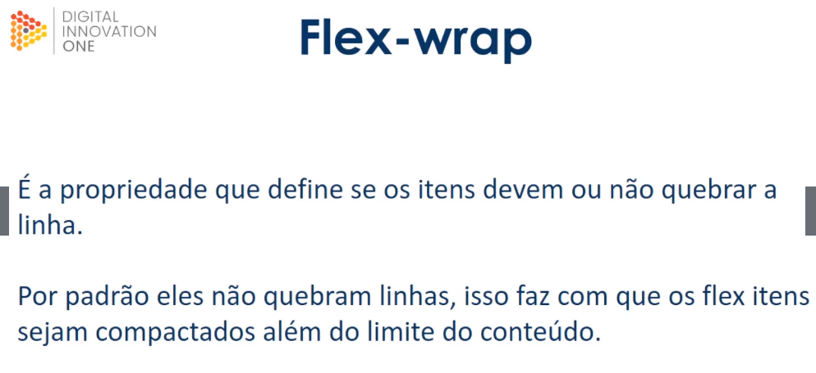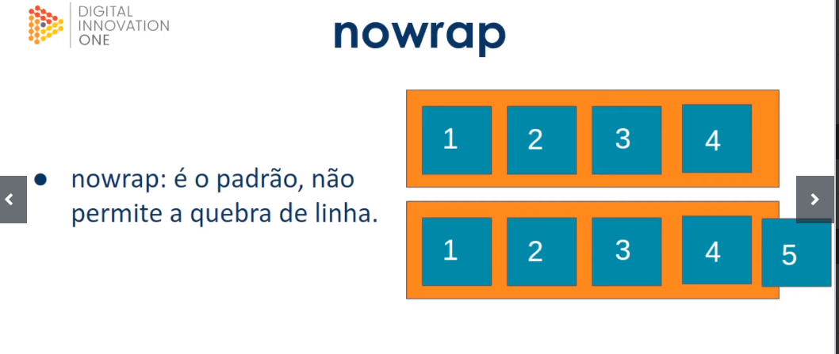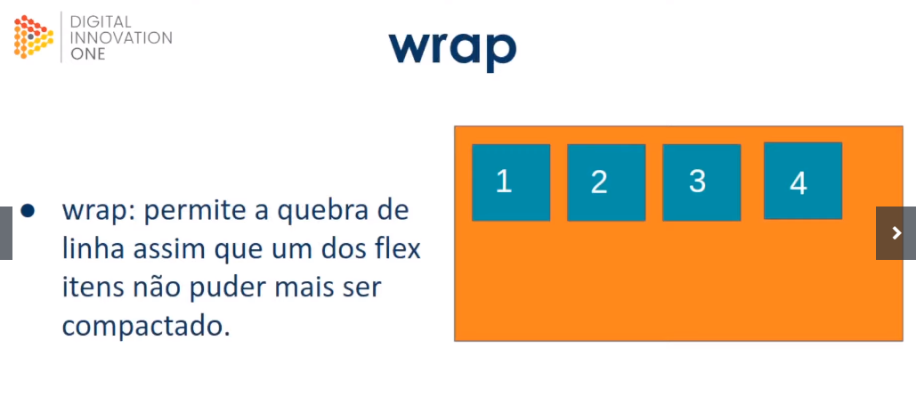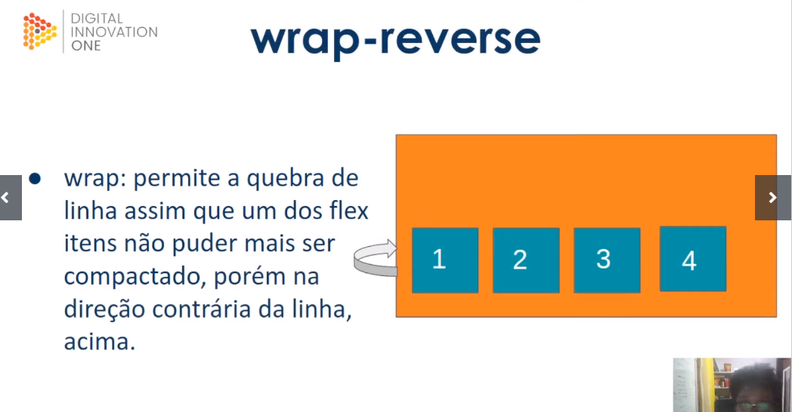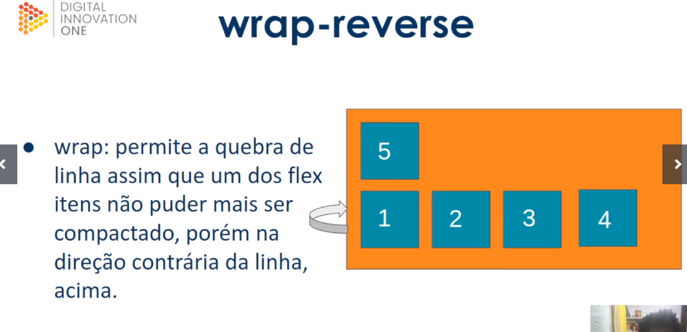

<!**DOCTYPE** html>

<**html** lang="en">

<**head**>

    <**meta** charset="UTF-8">

    <**meta** http-equiv="X-UA-Compatible" content="IE=edge">

    <**meta** name="viewport" content="width=device-width, initial-scale=1.0">

    <**title**>Fundamentos - flex wrap</**title**>

    <**style**>

        .flex-container{

            display: flex;

            height: 150px;

            border: 2px solid black;

            max-width: 300px;

            flex-direction:column

        }

        .item{

            font-size: 24px;

            height: 50%;

            text-align: center;

            min-width: 100px;

            line-height: 50px;

        }

        .nowrap{

            flex-wrap: nowrap;

        }

        .wrap{

            flex-wrap: wrap;

        }

        .wrap-reverse{

            flex-wrap:wrap-reverse;

        }

        .blue{

            background-color: blue;

        }

        .green{

            background-color: green;

        }

        .orange{

            background-color: orange;

        }

    </**style**>

</**head**>

<**body**>

    <**h1**>no wrap</**h1**>

    <**div** class="flex-container">

        <**div** class="item orange">1</**div**>

        <**div** class="item green">2</**div**>

        <**div** class="item blue">3</**div**>

        <**div** class="item orange">3</**div**>

    </**div**>

    <**h1**>wrap</**h1**>

    <**div** class="flex-container wrap">

        <**div** class="item green">1</**div**>

        <**div** class="item blue">2</**div**>

        <**div** class="item orange">3</**div**>

    </**div**>

    <**h1**>wrap reverse</**h1**>

    <**div** class="flex-container wrap-reverse">

        <**div** class="item green">1</**div**>

        <**div** class="item blue">2</**div**>

        <**div** class="item orange">3</**div**>

        <**div** class="item orange">4</**div**>

    </**div**>

</**body**>

</**html**>





<!**DOCTYPE** html>

<**html** lang="en">

<**head**>

    <**meta** charset="UTF-8">

    <**meta** http-equiv="X-UA-Compatible" content="IE=edge">

    <**meta** name="viewport" content="width=device-width, initial-scale=1.0">

    <**title**>Fundamentos -  flex flow</**title**>

    <**style**>

        .flex-container{

            display: flex;

            border: 1px solid black;

            max-width: 500px;

            margin-bottom: 10px;

        }

        .default{

            flex-flow: row nowrap;

        }

        .wrap{

            flex-flow: row wrap;

        }

        .wrap-reverse{

            flex-flow: row wrap-reverse;

        }

        .r-nowrap{

            flex-flow: row-reverse nowrap;

        }

        .r-wrap{

            flex-flow: row-reverse wrap;

        }

        .rr-wrap{

            flex-flow: row-reverse wrap-reverse;

        }

        .item{

            background-color: blueviolet;

            margin: 5px;

            color: white;

            text-align: center;

            width: 100px;

            height: 50px;

            line-height:50px;

        }

    </**style**>

</**head**>

<**body**>

    <**h1**>Default nowrap</**h1**>

    <**div** class="flex-container default">

        <**div** class="item">1</**div**>

        <**div** class="item">2</**div**>

        <**div** class="item">3</**div**>

        <**div** class="item">4</**div**>

        <**div** class="item">5</**div**>

    </**div**>

    <**h1**>wrap</**h1**>

    <**div** class="flex-container wrap">

        <**div** class="item">1</**div**>

        <**div** class="item">2</**div**>

        <**div** class="item">3</**div**>

        <**div** class="item">4</**div**>

        <**div** class="item">5</**div**>

        <**div** class="item">6</**div**>

    </**div**>

    <**h1**>Wrap-Reverse</**h1**>

    <**div** class="flex-container wrap-reverse">

        <**div** class="item">1</**div**>

        <**div** class="item">2</**div**>

        <**div** class="item">3</**div**>

        <**div** class="item">4</**div**>

        <**div** class="item">5</**div**>

        <**div** class="item">6</**div**>

        <**div** class="item">7</**div**>

        <**div** class="item">8</**div**>

    </**div**>

    <**h1**>Row-reverse now wrap</**h1**>

    <**div** class="flex-container r-nowrap">

        <**div** class="item">1</**div**>

        <**div** class="item">2</**div**>

        <**div** class="item">3</**div**>

        <**div** class="item">4</**div**>

        <**div** class="item">5</**div**>

        <**div** class="item">6</**div**>

        <**div** class="item">7</**div**>

        <**div** class="item">8</**div**>

        <**div** class="item">9</**div**>

        <**div** class="item">10</**div**>

    </**div**>

    <**h1**>Row-reverse  wrap</**h1**>

    <**div** class="flex-container r-wrap">

        <**div** class="item">1</**div**>

        <**div** class="item">2</**div**>

        <**div** class="item">3</**div**>

        <**div** class="item">4</**div**>

        <**div** class="item">5</**div**>

        <**div** class="item">6</**div**>

        <**div** class="item">7</**div**>

        <**div** class="item">8</**div**>

        <**div** class="item">9</**div**>

        <**div** class="item">10</**div**>

    </**div**>

    <**h1**>Row-reverse  wrap-reverse</**h1**>

    <**div** class="flex-container rr-wrap">

        <**div** class="item">1</**div**>

        <**div** class="item">2</**div**>

        <**div** class="item">3</**div**>

        <**div** class="item">4</**div**>

        <**div** class="item">5</**div**>

        <**div** class="item">6</**div**>

        <**div** class="item">7</**div**>

        <**div** class="item">8</**div**>

        <**div** class="item">9</**div**>

        <**div** class="item">10</**div**>

    </**div**>

</**body**>

</**html**>







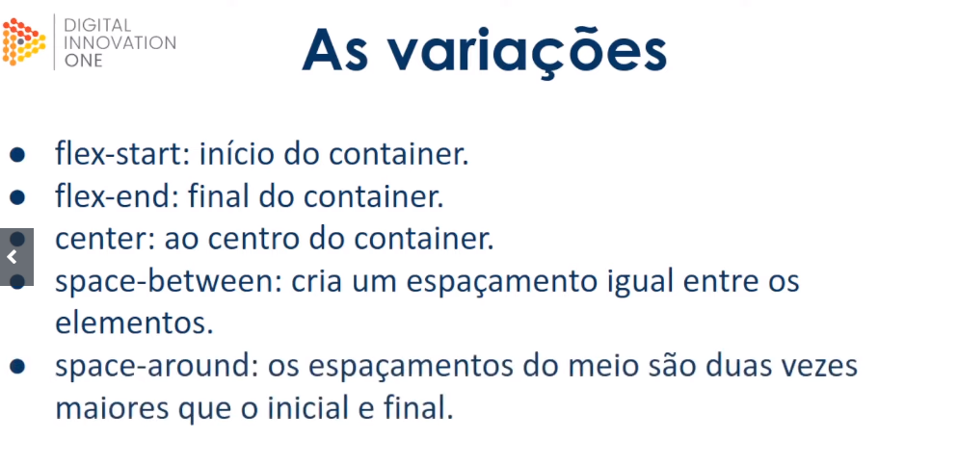

<!**DOCTYPE** html>

<**html** lang="en">

<**head**>

    <**meta** charset="UTF-8">

    <**meta** http-equiv="X-UA-Compatible" content="IE=edge">

    <**meta** name="viewport" content="width=device-width, initial-scale=1.0">

    <**title**>Fundamentos - justify-content</**title**>

    <**style**>

        .container{

            max-width: 400px;

            border: 1px solid black;

            margin: 0;

            display: flex;

        }

        .item{

            background-color: blueviolet;

            margin: 5px;

            text-align:center;

            color: white;

        }

        .flex-start{

            justify-content: flex-start;

        }

        .flex-end{

            justify-content: flex-end;

        }

        .center{

            justify-content:center;

        }

        .space-between{

            justify-content:space-between;

        }

        .space-around{

            justify-content:space-around;

        }

        .column{

            flex-direction: column;

            min-height: 200px;

        }

    </**style**>

</**head**>

<**body**>

    <**h1**>row</**h1**>

    <**p**>flex-start</**p**>

    <**section** class="container flex-start">

        <**div** class="item">1</**div**>

        <**div** class="item">item 2</**div**>

        <**div** class="item">outro 3</**div**>

    </**section**>

    <**p**>flex-end</**p**>

    <**section** class="container flex-end">

        <**div** class="item">1</**div**>

        <**div** class="item">item 2</**div**>

        <**div** class="item">outro 3</**div**>

    </**section**>

    <**p**>center</**p**>

    <**section** class="container center">

        <**div** class="item">1</**div**>

        <**div** class="item">item 2</**div**>

        <**div** class="item">outro 3</**div**>

        <**div** class="item">4</**div**>

        <**div** class="item">5</**div**>

    </**section**>

    <**p**>space-between</**p**>

    <**section** class="container space-between">

        <**div** class="item">1</**div**>

        <**div** class="item">item 2</**div**>

        <**div** class="item">outro 3</**div**>

        <**div** class="item">4</**div**>

        <**div** class="item">5</**div**>

    </**section**>

    <**p**>space-around</**p**>

    <**section** class="container space-around">

        <**div** class="item">1</**div**>

        <**div** class="item">item 2</**div**>

        <**div** class="item">outro 3</**div**>

        <**div** class="item">4</**div**>

        <**div** class="item">5</**div**>

    </**section**>

    <**h1**>column</**h1**>

    <**p**>flex-start(column)</**p**>

    <**section** class="container flex-start column">

        <**div** class="item">1</**div**>

        <**div** class="item">item 2</**div**>

        <**div** class="item">outro 3</**div**>

        <**div** class="item">4</**div**>

        <**div** class="item">5</**div**>

    </**section**>

    <**p**>flex-end(column)</**p**>

    <**section** class="container flex-end column">

        <**div** class="item">1</**div**>

        <**div** class="item">item 2</**div**>

        <**div** class="item">outro 3</**div**>

        <**div** class="item">4</**div**>

        <**div** class="item">5</**div**>

    </**section**>

    <**p**>flex-center(column)</**p**>

    <**section** class="container center column">

        <**div** class="item">1</**div**>

        <**div** class="item">item 2</**div**>

        <**div** class="item">outro 3</**div**>

        <**div** class="item">4</**div**>

        <**div** class="item">5</**div**>

    </**section**>

    <**p**>space-between(column)</**p**>

    <**section** class="container space-between column">

        <**div** class="item">1</**div**>

        <**div** class="item">item 2</**div**>

        <**div** class="item">outro 3</**div**>

        <**div** class="item">4</**div**>

        <**div** class="item">5</**div**>

    </**section**>

    <**p**>space-around(column)</**p**>

    <**section** class="container space-around column">

        <**div** class="item">1</**div**>

        <**div** class="item">item 2</**div**>

        <**div** class="item">outro 3</**div**>

        <**div** class="item">4</**div**>

        <**div** class="item">5</**div**>

    </**section**>

</**body**>

</**html**>

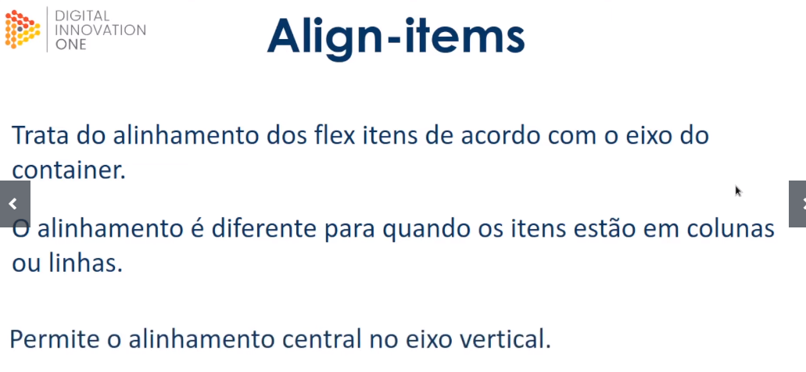

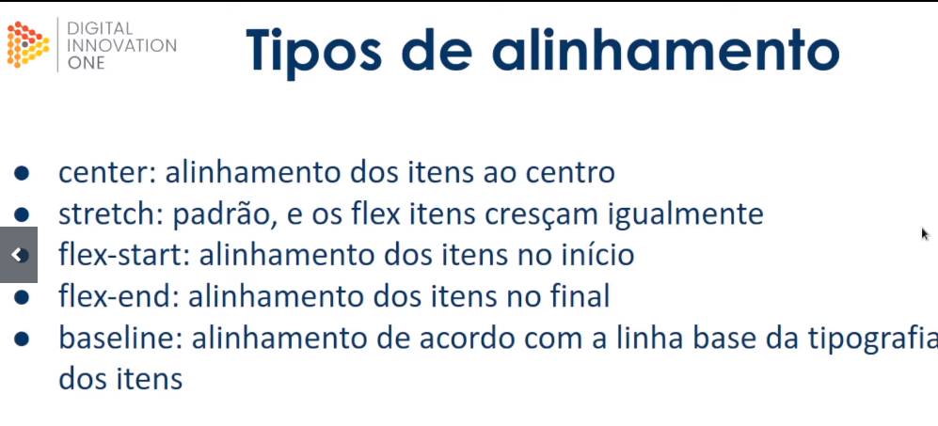

<!**DOCTYPE** html>

<**html** lang="en">

<**head**>

    <**meta** charset="UTF-8">

    <**meta** http-equiv="X-UA-Compatible" content="IE=edge">

    <**meta** name="viewport" content="width=device-width, initial-scale=1.0">

    <**title**>Fundamentos - align items</**title**>

    <!-- DeterminaR os estilos css -->

    <**style**>

        .container{

            max-width: 350px; /*Determina a largura maxima */

            border: 1px solid black; /*Permite determinar estilo e cor da borda */

            display: flex; /*Determina o comportamento de exibição de um elemento */

        }

        .item{

            background-color: blueviolet;/*A background-colorpropriedade define a cor de fundo de um elemento.*/

            margin:5px;/*As margens são usadas para criar espaço ao redor dos elementos*/

            color: white;/*Define as cores dos elementos*/

            text-align: center;/*Define o alinhamento do texto*/

            flex: 1;

        }

        .center{

            align-items: center;/*Propriedade para alinhamento de items*/

        }

        .stretch{

            align-items: stretch;

        }

        .flex-start{

            align-items: flex-start;

        }

        .flex-end{

            align-items: flex-end;

        }

        .baseline{

            align-items: baseline;

        }

        .column{

            flex-direction: column;

        }

        .central{

            height: 400px;

            justify-content: center;

            align-items: center;

        }

        .central .item{

            flex:0;

            padding:20px;

        }

    </**style**>

</**head**>

<**body**>

    <**h1**>ROW</**h1**>

    <**p**>center</**p**>

    <**section** class="container center">

        <**div** class="item">Item 1</**div**>

        <**div** class="item">Lorwe ipsum dolor sit amet</**div**>

        <**div** class="item">Item 3 mais algum texto.Lipsum</**div**>

    </**section**>

    <**p**>strectch</**p**>

    <**section** class="container stretch">

        <**div** class="item">Item 1</**div**>

        <**div** class="item">Lorwe ipsum dolor sit amet.Lorwe ipsum dolor sit ametLorwe ipsum dolor sit ametLorwe ipsum dolor sit amet</**div**>

        <**div** class="item">Item 3 mais algum texto.Lipsum</**div**>

    </**section**>

    <**p**>flex-start</**p**>

    <**section** class="container flex-start">

        <**div** class="item">Item 1</**div**>

        <**div** class="item">Lorwe ipsum dolor sit amet.Lorwe ipsum dolor sit ametLorwe ipsum dolor sit ametLorwe ipsum dolor sit amet</**div**>

        <**div** class="item">Item 3 mais algum texto.Lipsum</**div**>

    </**section**>

    <**p**>flex-end</**p**>

    <**section** class="container flex-end">

        <**div** class="item">Item 1</**div**>

        <**div** class="item">Lorwe ipsum dolor sit amet.Lorwe ipsum dolor sit ametLorwe ipsum dolor sit ametLorwe ipsum dolor sit amet</**div**>

        <**div** class="item">Item 3 mais algum texto.Lipsum</**div**>

    </**section**>

    <**p**>baseline</**p**>

    <**section** class="container baseline">

        <**div** class="item"><**br**>Item 1</**div**>

        <**div** class="item">Lorwe ipsum dolor sit amet.Lorwe ipsum dolor sit ametLorwe ipsum dolor sit ametLorwe ipsum dolor sit amet</**div**>

        <**div** class="item">Item 3 mais algum texto.Lipsum</**div**>

    </**section**>

    <**h1**>COLUMN</**h1**>

    <**section** class="container flex-start column">

        <**div** class="item">Item 1</**div**>

        <**div** class="item">Lorwe ipsum dolor sit amet.Lorwe ipsum dolor sit ametLorwe ipsum dolor sit ametLorwe ipsum dolor sit amet</**div**>

        <**div** class="item">Item 3 mais algum texto.Lipsum</**div**>

    </**section**>

    <**p**>flex-end</**p**>

    <**section** class="container flex-end column">

        <**div** class="item">Item 1</**div**>

        <**div** class="item">Lorwe ipsum dolor sit amet.Lorwe ipsum dolor sit ametLorwe ipsum dolor sit ametLorwe ipsum dolor sit amet</**div**>

        <**div** class="item">Item 3 mais algum texto.Lipsum</**div**>

    </**section**>

    <**section** class="container center column">

        <**div** class="item">Item 1</**div**>

        <**div** class="item">Lorwe ipsum dolor sit amet</**div**>

        <**div** class="item">Item 3 mais algum texto.Lipsum</**div**>

    </**section**>

    <**p**>baseline</**p**>

    <**section** class="container baseline column">

        <**div** class="item"><**br**>Item 1</**div**>

        <**div** class="item">Lorwe ipsum dolor sit amet.Lorwe ipsum dolor sit ametLorwe ipsum dolor sit ametLorwe ipsum dolor sit amet</**div**>

        <**div** class="item">Item 3 mais algum texto.Lipsum</**div**>

    </**section**>

    <**p**>alinhamento central à tela</**p**>

    <**section** class="container central center">

        <**div** class="item">Lorwe ipsum dolor sit amet.Lorwe ipsum dolor sit ametLorwe ipsum dolor sit ametLorwe ipsum dolor sit amet</**div**>

    </**section**>

</**body**>

</**html**>

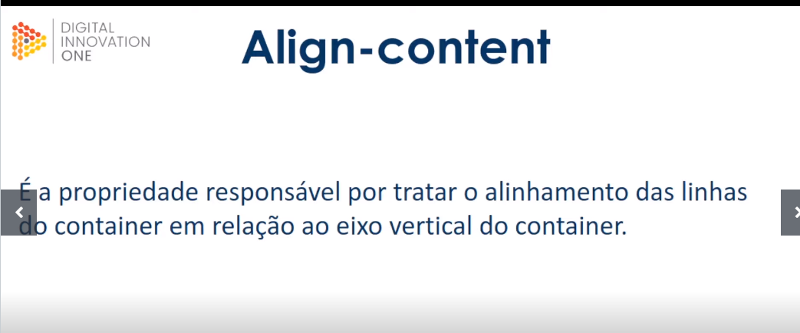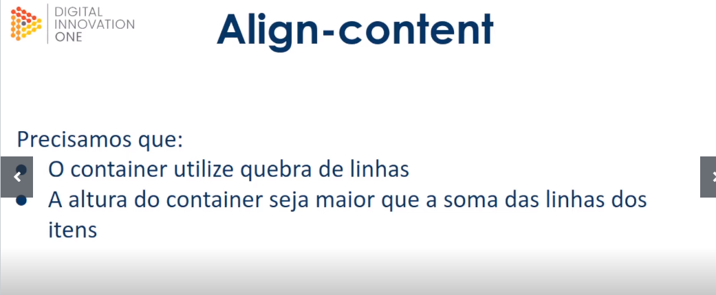

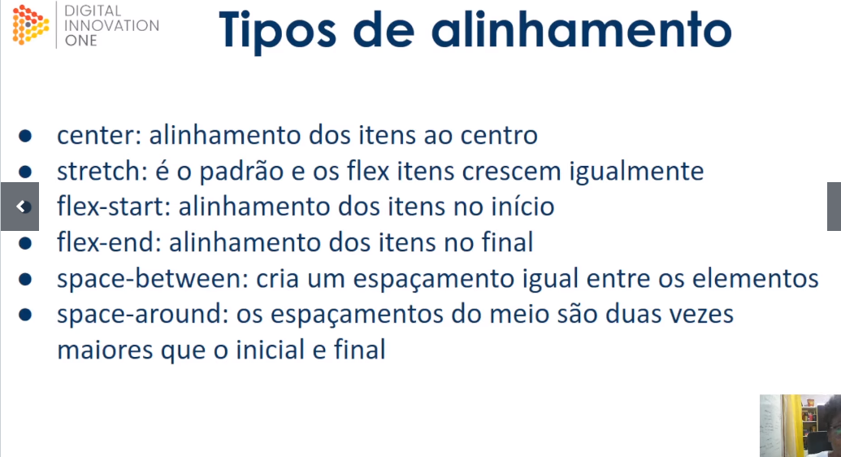

<!**DOCTYPE** html>

<**html** lang="en">

<**head**>

    <**meta** charset="UTF-8">

    <**meta** http-equiv="X-UA-Compatible" content="IE=edge">

    <**meta** name="viewport" content="width=device-width, initial-scale=1.0">

    <**title**>Fundamentos - align content</**title**>

    <**style**>

        .container{

            height: 400px;

            max-width: 300px;

            margin:0 auto;

            display: flex;

            flex-wrap: wrap;

            border: 1px solid black;

        }

        .item{

            background-color: orangered;

            padding-right: 0 5px;

            margin: 5px;

            flex: 1;

            text-align: center;

            color: white;

        }

        .streech{

            align-content: stretch;

        }

        .center{

            align-content: center;

        }

        .flex-start{

            align-content: flex-start;

        }

        .flex-end{

            align-content: flex-end;

        }

        .space-around{

            align-content: space-around;

        }

        .space-between{

            align-content: space-between;

        }

    </**style**>

</**head**>

<**body**>

    <**p**>stretch</**p**>

    <**div** class="container strectch">

        <**div** class="item">Lorem Ipsum é simplesmente um texto</**div**>

        <**div** class="item">Lorem Ipsum é simplesmente </**div**>

        <**div** class="item">Lorem Ipsum é simplesmente um texto</**div**>

        <**div** class="item">Lorem Ipsum é simplesmente um texto fictício da indústria tipográfica e de impressão.  </**div**>

        <**div** class="item">Lorem Ipsum é simplesmente um texto</**div**>

        <**div** class="item">Lorem Ipsum é simplesmente um texto</**div**>

        <**div** class="item">Lorem Ipsum é simplesmente um texto</**div**>

    </**div**>

    <**p**>center</**p**>

    <**div** class="container center">

        <**div** class="item">Lorem Ipsum é simplesmente um texto</**div**>

        <**div** class="item">Lorem Ipsum é simplesmente </**div**>

        <**div** class="item">Lorem Ipsum é simplesmente um texto</**div**>

        <**div** class="item">Lorem Ipsum é simplesmente um texto fictício da indústria tipográfica e de impressão.  </**div**>

        <**div** class="item">Lorem Ipsum é simplesmente um texto</**div**>

        <**div** class="item">Lorem Ipsum é simplesmente um texto</**div**>

        <**div** class="item">Lorem Ipsum é simplesmente um texto</**div**>

    </**div**>

    <**p**>flex-start</**p**>

    <**div** class="container flex-start">

        <**div** class="item">Lorem Ipsum é simplesmente um texto</**div**>

        <**div** class="item">Lorem Ipsum é simplesmente </**div**>

        <**div** class="item">Lorem Ipsum é simplesmente um texto</**div**>

        <**div** class="item">Lorem Ipsum é simplesmente um texto fictício da indústria tipográfica e de impressão.  </**div**>

        <**div** class="item">Lorem Ipsum é simplesmente um texto</**div**>

        <**div** class="item">Lorem Ipsum é simplesmente um texto</**div**>

        <**div** class="item">Lorem Ipsum é simplesmente um texto</**div**>

    </**div**>

    <**p**>flex-end</**p**>

    <**div** class="container flex-end">

        <**div** class="item">Lorem Ipsum é simplesmente um texto</**div**>

        <**div** class="item">Lorem Ipsum é simplesmente </**div**>

        <**div** class="item">Lorem Ipsum é simplesmente um texto</**div**>

        <**div** class="item">Lorem Ipsum é simplesmente um texto fictício da indústria tipográfica e de impressão.  </**div**>

        <**div** class="item">Lorem Ipsum é simplesmente um texto</**div**>

        <**div** class="item">Lorem Ipsum é simplesmente um texto</**div**>

        <**div** class="item">Lorem Ipsum é simplesmente um texto</**div**>

    </**div**>

    <**p**>space-around</**p**>

    <**div** class="container space-around">

        <**div** class="item">Lorem Ipsum é simplesmente um texto</**div**>

        <**div** class="item">Lorem Ipsum é simplesmente </**div**>

        <**div** class="item">Lorem Ipsum é simplesmente um texto</**div**>

        <**div** class="item">Lorem Ipsum é simplesmente um texto fictício da indústria tipográfica e de impressão.  </**div**>

        <**div** class="item">Lorem Ipsum é simplesmente um texto</**div**>

        <**div** class="item">Lorem Ipsum é simplesmente um texto</**div**>

        <**div** class="item">Lorem Ipsum é simplesmente um texto</**div**>

    </**div**>

    <**p**>flex-end</**p**>

    <**div** class="container space-between">

        <**div** class="item">Lorem Ipsum é simplesmente um texto</**div**>

        <**div** class="item">Lorem Ipsum é simplesmente </**div**>

        <**div** class="item">Lorem Ipsum é simplesmente um texto</**div**>

        <**div** class="item">Lorem Ipsum é simplesmente um texto fictício da indústria tipográfica e de impressão.  </**div**>

        <**div** class="item">Lorem Ipsum é simplesmente um texto</**div**>

        <**div** class="item">Lorem Ipsum é simplesmente um texto</**div**>

        <**div** class="item">Lorem Ipsum é simplesmente um texto</**div**>

    </**div**>

</**body**>

</**html**>

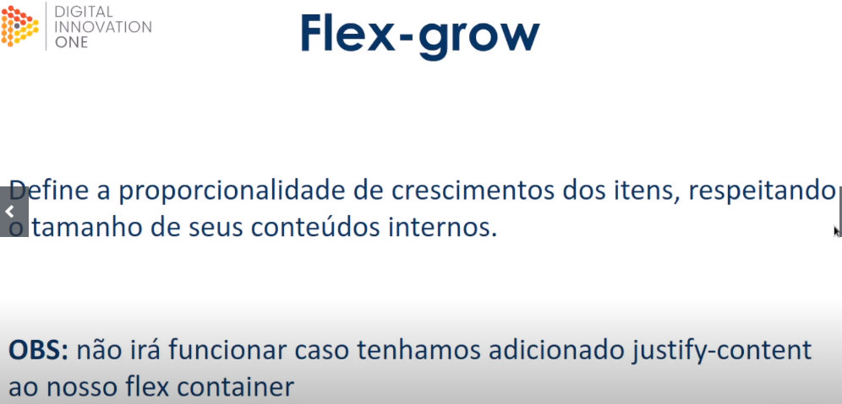

<!**DOCTYPE** html>

<**html** lang="en">

<**head**>

    <**meta** charset="UTF-8">

    <**meta** http-equiv="X-UA-Compatible" content="IE=edge">

    <**meta** name="viewport" content="width=device-width, initial-scale=1.0">

    <**title**>Fundamentos - flex grow</**title**>

    <**style**>

        .flex-container{

            display: flex;

            border: 2px solid black;

            max-width: 300px;

            margin-bottom: 20px;

        }

        .item{

            background-color: orangered;

            margin: 5px;

            padding: 10px;

            text-align: center;

            color: white;

        }

        .fg-0{

            flex-grow: 0;

        }

        .fg-1{

            flex-grow: 1;

        }

        .fg-2{

            flex-grow: 2;

        }

        .fg-3{

            flex-grow: 3;

        }

    </**style**>

</**head**>

<**body**>

    <**p**>flex-grow 0</**p**>

    <**div** class="flex-container">

        <**div** class="item fg-0">A</**div**>

        <**div** class="item fg-0">B</**div**>

        <**div** class="item fg-0">C</**div**>

        <**div** class="item fg-0">D</**div**>

    </**div**>

    <**p**>flex-grow 1</**p**>

    <**div** class="flex-container">

        <**div** class="item fg-1">A</**div**>

        <**div** class="item fg-1">B</**div**>

        <**div** class="item fg-1">C</**div**>

        <**div** class="item fg-1">D</**div**>

    </**div**>

    <**p**>flex-alternados</**p**>

    <**div** class="flex-container">

        <**div** class="item fg-1">A</**div**>

        <**div** class="item fg-2">B</**div**>

        <**div** class="item fg-2">C</**div**>

        <**div** class="item fg-1">D</**div**>

    </**div**>

    <**p**>flex-grow 3</**p**>

    <**div** class="flex-container">

        <**div** class="item fg-3">AAAAAAAAA</**div**>

        <**div** class="item fg-3">BBBB</**div**>

        <**div** class="item fg-3">C</**div**>

        <**div** class="item fg-3">D</**div**>

    </**div**>

</**body**>

</**html**>s



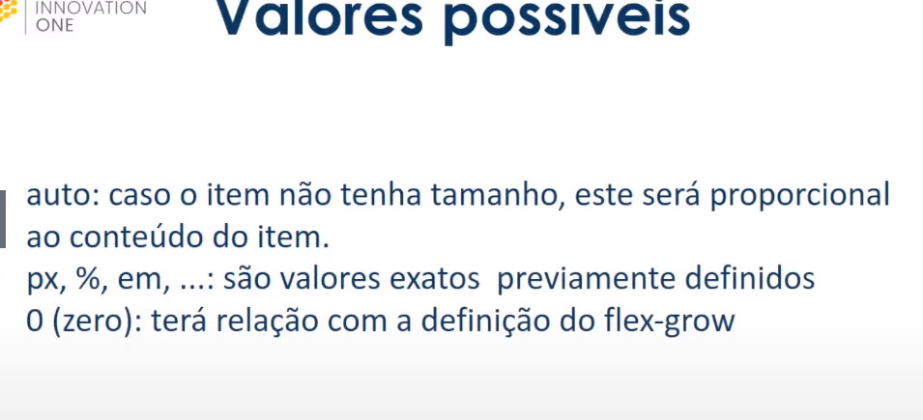

## Sddddddddddddddddddddddddddddddddddddddddddddddddddddddddddddddddddddddddddddddddddddddddddddddd

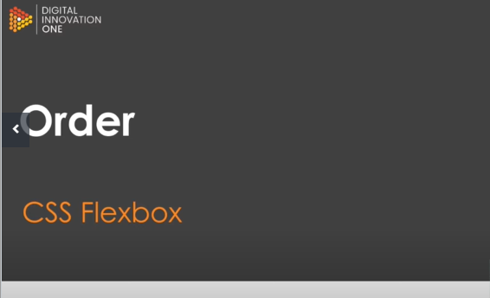

CÓDIGO 10

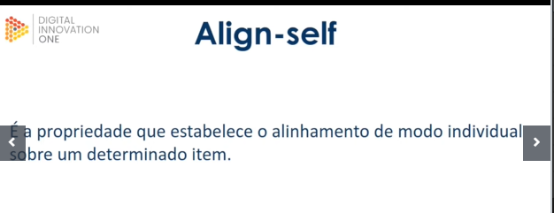

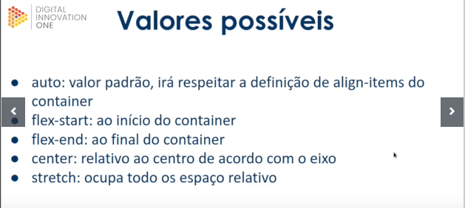

Código 13

